This is a guide to completing the SOS-PD audit tool, for use in UK PICU’s using Comfort B and SOS-PD scoring. It may be adapted by each PICU to suit their needs. This audit is not mandatory, but may be helpful in establishing and monitoring SOS-PD scoring. Frequency of audit can be determined by individual PICU’s, though a minimum of 1 audit per month is recommended. Results can highlight areas of delirium scoring which do not meet standards and help target teaching and learning.
The SOS-PD scoring sheet and other resources can be downloaded from the UK Paediatric Delirium Group website @ https://www.qub.ac.uk/sites/uk-paediatric-delirium-group/
Further details on how to complete each column can be found by hovering mouse pointer over the small red dot at in the top right corner of each column header.
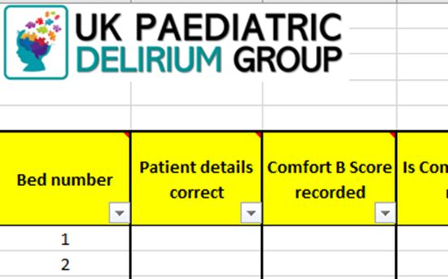
Hover mouse pointer over this corner and further information should appear

Audit details
Complete audit details at the top of the spreadsheet.
Insert Unit name
Insert Audit date
Cell is auto formatted
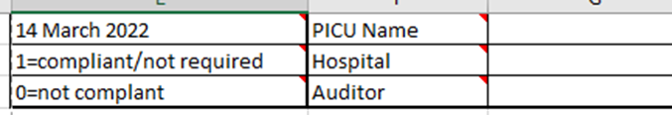
Insert Auditor name
Insert Hospital name

Column A – Bed number
Record each bed number included in the audit. Additional rows may be added by following the instructions below. Formulas for each column should be automatically copied in to the new row. Rows may deleted without affecting the table formulas if they are not required, for example – if there is no patient in bed 7, the row may be deleted or number changed to correspond to another bed.
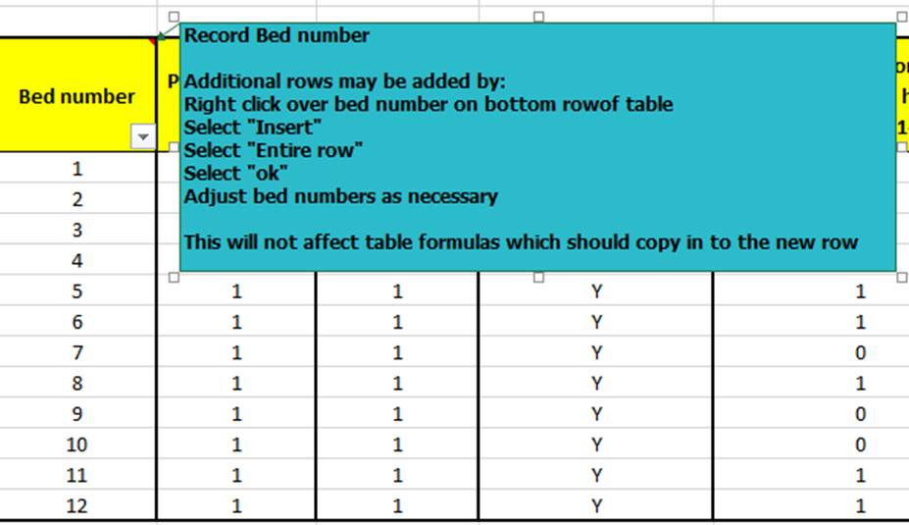
Insert new row by clicking on the last row
Add new rows and insert bed numbers as required

Column B – Patient Details
Check patient chart has correct details. This may be a label or transcribed. If using an electronic format, check patient details are correct on the system.
If details are correct, score ‘1’.
If details are incorrect, score ‘0’.
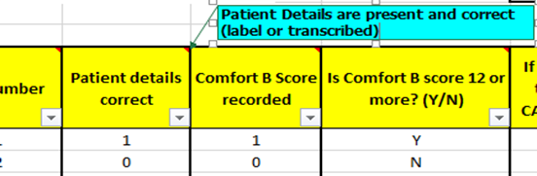

SOS-PD should be recorded at least once per shift from admission if Comfort B is 12 or more. The following parts of the audit must be taken from most recent opportunity to record in the 24 hour period prior to audit.

Column C – Comfort B Score recorded
Check patient chart for Comfort B score. If Comfort B is not recorded, chart compliance will automatically default to zero as Comfort B must be recorded for all patients.
If recorded, score ‘1’.
If not recorded score ‘0’.
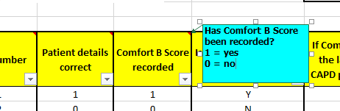

Column D – Is Comfort B Score 12 or more?
Comfort B score should always be recorded on the chart.
If Comfort B score has been recorded as 12 or more insert ‘Y’.
If Comfort B score is not recorded or is 11 or less score ‘N’.
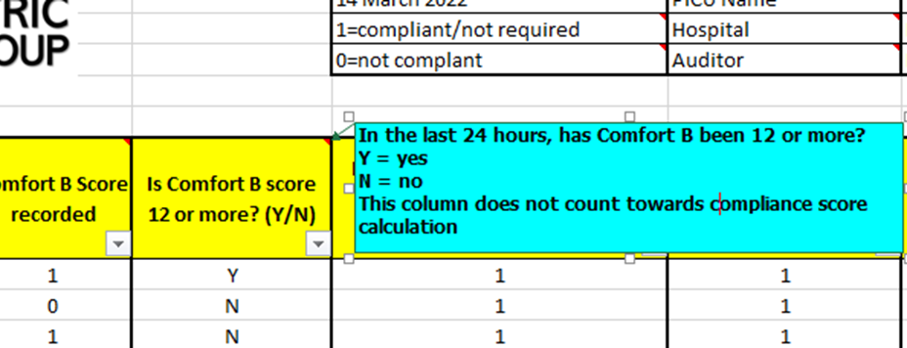

Column E - If Comfort B is 12 or more in the last 24 hours, are ALL SOS-PD parameters scored?
If Comfort B score is 12 or more SOS-PD must be assessed using the paediatric delirium assessment domains on the chart.
If SOS-PD assessment has been completed for all paediatric delirium domains OR SOS-PD is not required as Comfort Score is less than 12 then score ‘1’.
IF SOS-PD assessment has not been completed but should have been as Comfort B score is 12 or more OR not completed in entirety score ‘0’.
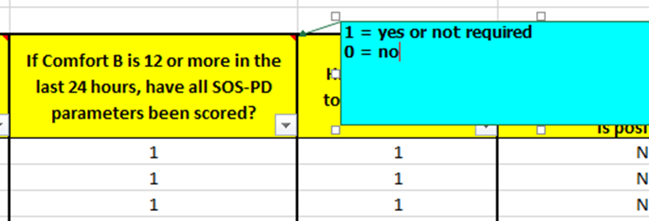

Column F - Has SOS-PD been totalled correctly?
Verify the SOS-PD score by adding all 8 domain scores together. Check this correlates with SOS-PD score recorded on the chart.
If SOS-PD score has been totalled correctly OR is not required as Comfort B score is less than 12, score ‘1’.
IF SOS-PD score is not correct OR has not been recorded but should have been, score ‘0’.
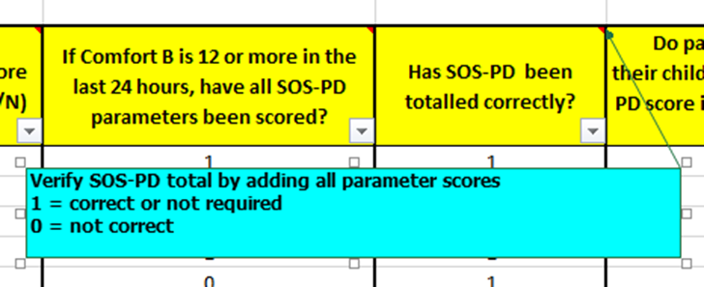

Column G – Do parents NOT recognise their child’s behavior AND/OR SOS-PD score is ≥ 4 OR symptom with * is positive??
It may be of interest to units to know how many patients are screening ‘delirium positive’ during the audit. This will not count towards compliance score.
Score ‘Y’ if Yes
Score ‘N’ if No or not screened
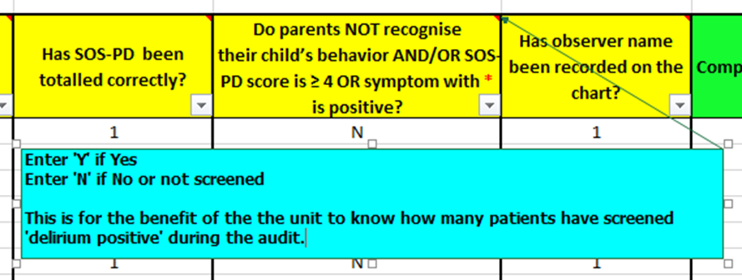
The number of patients where parents do NOT recognise their child’s behaviour AND/OR SOS-PD score is ≥ 4 OR symptom with * is positive will be calculated as a percentage of all audited patients at the bottom of this column.
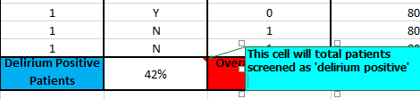

Column H - Has observer name been recorded on the chart?
The initials of the staff member conducting the SOS-PD assessment should be clearly documented at the top of the chart. On electronic systems this should also be easily identifiable. This must be completed for all patients even if SOS-PD score is not required.
Score ‘1’ if this has been completed
Score ‘0’ if this is blank / not correct
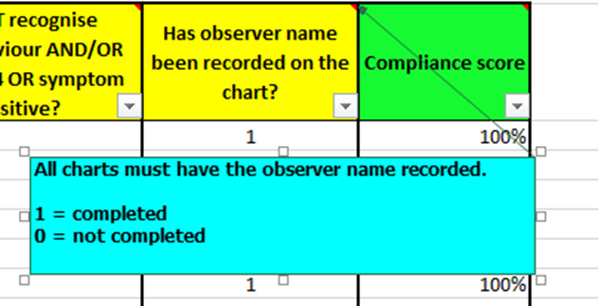

Column I – Compliance score
Each cell in this column has a formula embedded which will auto calculate the compliance score for each row and overall compliance score for the audit.
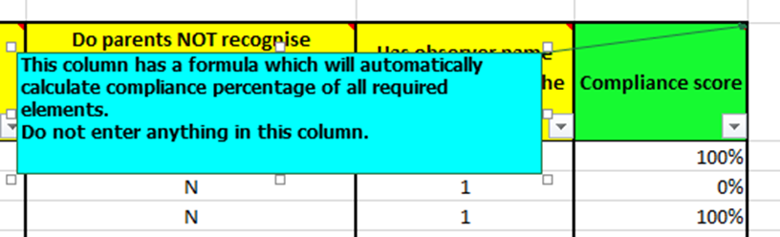

Do not enter a value in this cell as the formula will be overwritten. If this occurs, ‘undo’ by clicking once on the arrow at the top left of the computer screen.
.
Click once here
If this does not work, copy and insert the formula from the cell above.
Completed audit tool should resemble this:
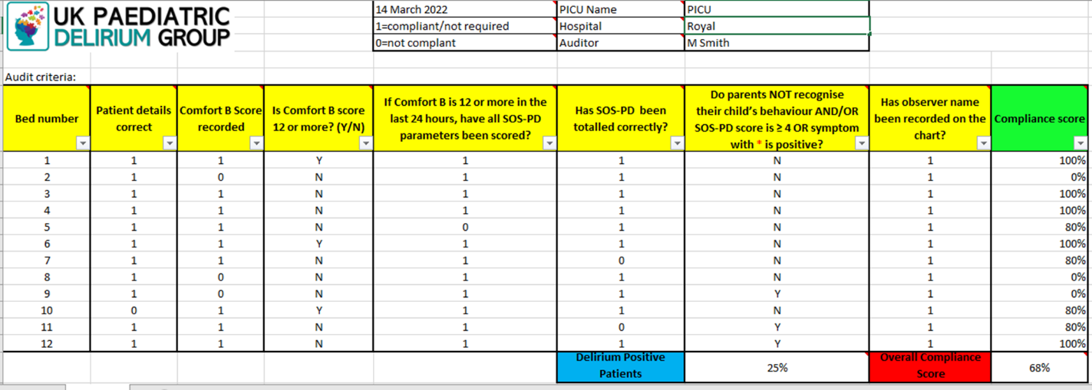

When the audit has been completed, a % score will be generated for each chart. An overall compliance score will be generated for the audit also. Individual units may wish to have a ‘pass’ score for audit reporting purposes. This threshold is for the unit to decide.
The UK delirium group has not recommended a ‘pass’ score but may periodically request units provide overall compliance scores to monitor implementation of delirium scoring across UK PICU’s. Identity of reporting units will remain confidential.
Finally, save the audit for future reference.
Please address any questions or feedback in relation to this audit tool to maeve.murray@northerntrust.hscni.net

