Dear QUB Student
What is VPC (Virtual primary Care)?
This resource is intended very much to complement your GP placement. We know that due to changes in consulting patterns since the Covid-19 pandemic, students may see less patients face-to-face. Virtual Primary Care is a digital learning resource which uses a selection of videos taken in GP practices in Birmingham, Bradford, Bristol, and London. The videos provide opportunities to observe and consider "real life" consultations (these are real GPs and patients, not actors).
The 150 diverse primary care consultations have been specifically selected, produced, and edited to assist with your learning. Each video has been tagged to the Learning General Practice principles and is accompanied by a summary, associated learning points, references, and suggested student activities.
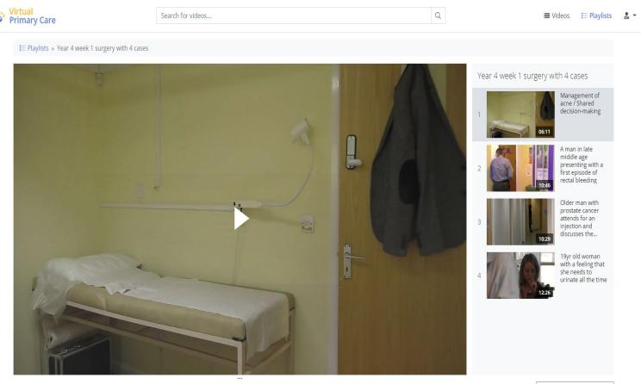
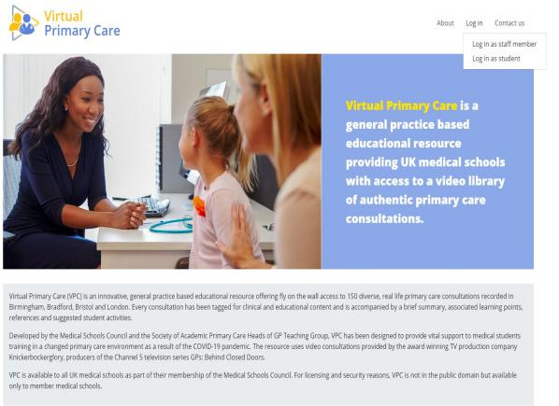

To access the video playlist
- You will receive an invitation in your QUB email inbox to login to Virtual Primary Care …………..
Dear ?, There has been an account created for this email address in the MSC Virtual Primary Care Platform. Please follow the link labelled "Activation Link" to confirm your email address and registration. You will need to set a personalized password for securing and activating your account. Activation Link: >>>>
******As the VPC platform is linked to MSCAA, if you already have access to MSCAA you can use the same log in details for MSCAA to log in to VPC. In this situation, you will not get an activation email.
- Click on the link in the email to create a Password to allow you to access the website for the first time
- You will need to log in using your student email and password to access the videos on the website https://vpc.medicalschoolscouncil.org.uk/
- Each year group will have a different video “GP surgery” playlist
- If you have any problems accessing the videos, email louise.sands@qub.a.cuk

